Asia-China-Blades-EBAY

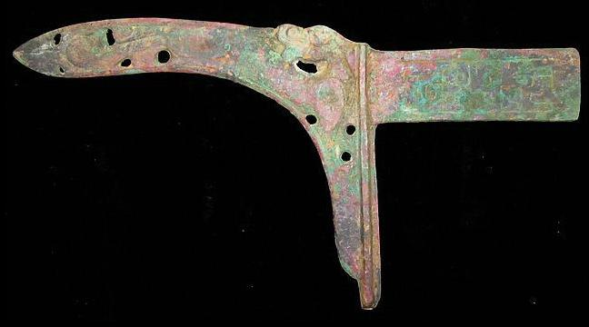

# WarringStatesPeriod 70 usd

SHAPE \* MERGEFORMAT 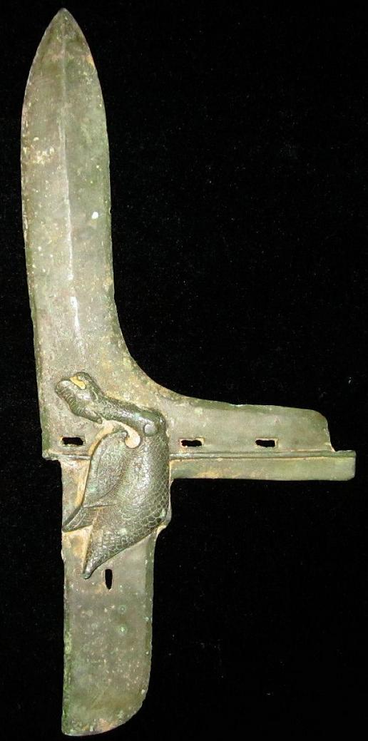

# SHANG 130

SHAPE \* MERGEFORMAT 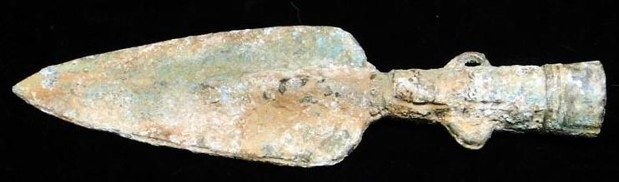

Warring States period 108

SHAPE \* MERGEFORMAT 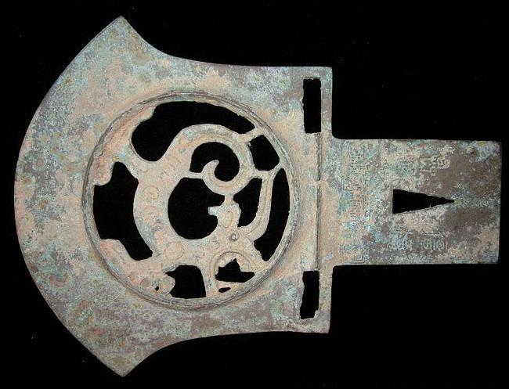

# SHANG 130

